Pretreated Stem Cells Lose Regenerative Capacity
September 28, 2015
Review of “Pre-treatment of Mesenchymal Stem Cells Manipulates Their Vasculoprotective Potential While Not Altering Their Homing within the Injured Gut” from Stem Cells by Stuart P. Atkinson
Mesenchymal stem cells (MSCs) are the go-to cell type for the control of inflammation [1] as once administered they can home and promote repair through various mechanisms. Enhancement of homing and adhesion to specific sites may improve MSC-based therapeutics [2] although little is understood regarding MSC-homing after administration or whether artificially enhancing this process provides any benefit.
Now, researchers from the laboratory of Neena Kalia (University of Birmingham, UK) have applied single-cell microscopy techniques to assess homing of MSCs to the injured mouse gut and have uncovered some interesting findings.
Their study, published in Stem Cells, found a similar level of MSC homing and limited cell adhesion in the injured and non-injured gut. While this did mediate some pro-regenerative effects, priming MSCs through pre-treatment with various inflammation-related factors did not improve homing, and actually caused MSCs to lose their pro-regenerative capabilities [3].
The study employed intravital microscopy to monitor adhesion in injured intestinal microvasculature [4], and initially the researchers found poor MSC adhesion to the gut lining and no enhancement following ischemia/reperfusion (IR) injury. The small and round shape of the adherent MSCs suggested vascular plugging as a mode of “adhesion”, but MSC treatment did lead to the improvement of blood flow and a reduction in neutrophil adhesion in the damaged gut (See Figure).
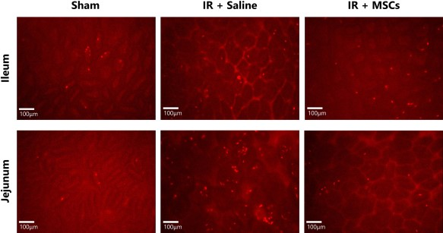
Pre-treatment with various factors hopes to “prime” cells to enhance adhesion and pro-regenerative function. In this study, pre-treatment with a range of factors (CXCL12, H2O2, TNFα, or IFNγ) did not enhance adhesion in vitro or in vivo. Treatment with TNFα and IFNγ did mediate a large and rapid release of Interleukin 6 (IL-6) from MSCs, which could enhance their anti-inflammatory and vasculoprotective effects even in the absence of improved adhesion or homing. However, pre-treating MSCs with these factors actually caused cells to lose some of their vital pro-regenerative characteristics: pre-treating cells inhibited the increase in blood flow and reduction in neutrophil number as previously observed with untreated MSCs.
This interesting study demonstrates both that MSCs adhere poorly to the gut mucosa, and that priming cells, in an attempt to boost adhesion, actually causes a loss in MSC pro-regenerative function. This is of obvious clinical importance, as MSC use in trials increases every year, and so, different strategies to boost MSC homing, adhesion, and pro-regenerative capabilities may be required.
References
- Swenson E and Theise N Stem cell therapeutics: potential in the treatment of inflammatory bowel disease. Clinical and experimental gastroenterology 2010;3:1-10.
- Kavanagh DP, Robinson J, and Kalia N Mesenchymal stem cell priming: fine-tuning adhesion and function. Stem Cell Rev 2014;10:587-599.
- Kavanagh DP, Suresh S, Newsome PN, et al. Pretreatment of Mesenchymal Stem Cells Manipulates Their Vasculoprotective Potential While Not Altering Their Homing Within the Injured Gut. Stem Cells 2015;33:2785-2797.
- Kavanagh DP, Yemm AI, Zhao Y, et al. Mechanisms of adhesion and subsequent actions of a haematopoietic stem cell line, HPC-7, in the injured murine intestinal microcirculation in vivo. PLoS One 2013;8:e59150.

